AI ASSIGNMENT-6.5

Name : R.Akshitha

Hall No. : 2303A52464

Batch : 36

**Task Description #1** (AI-Based Code Completion for Conditional

Eligibility Check)

Task: Use an AI tool to generate eligibility logic.

Prompt:

“Generate Python code to check voting eligibility based on age and

citizenship.”

Expected Output:

• AI-generated conditional logic.

• Correct eligibility decisions.

• Explanation of conditions.

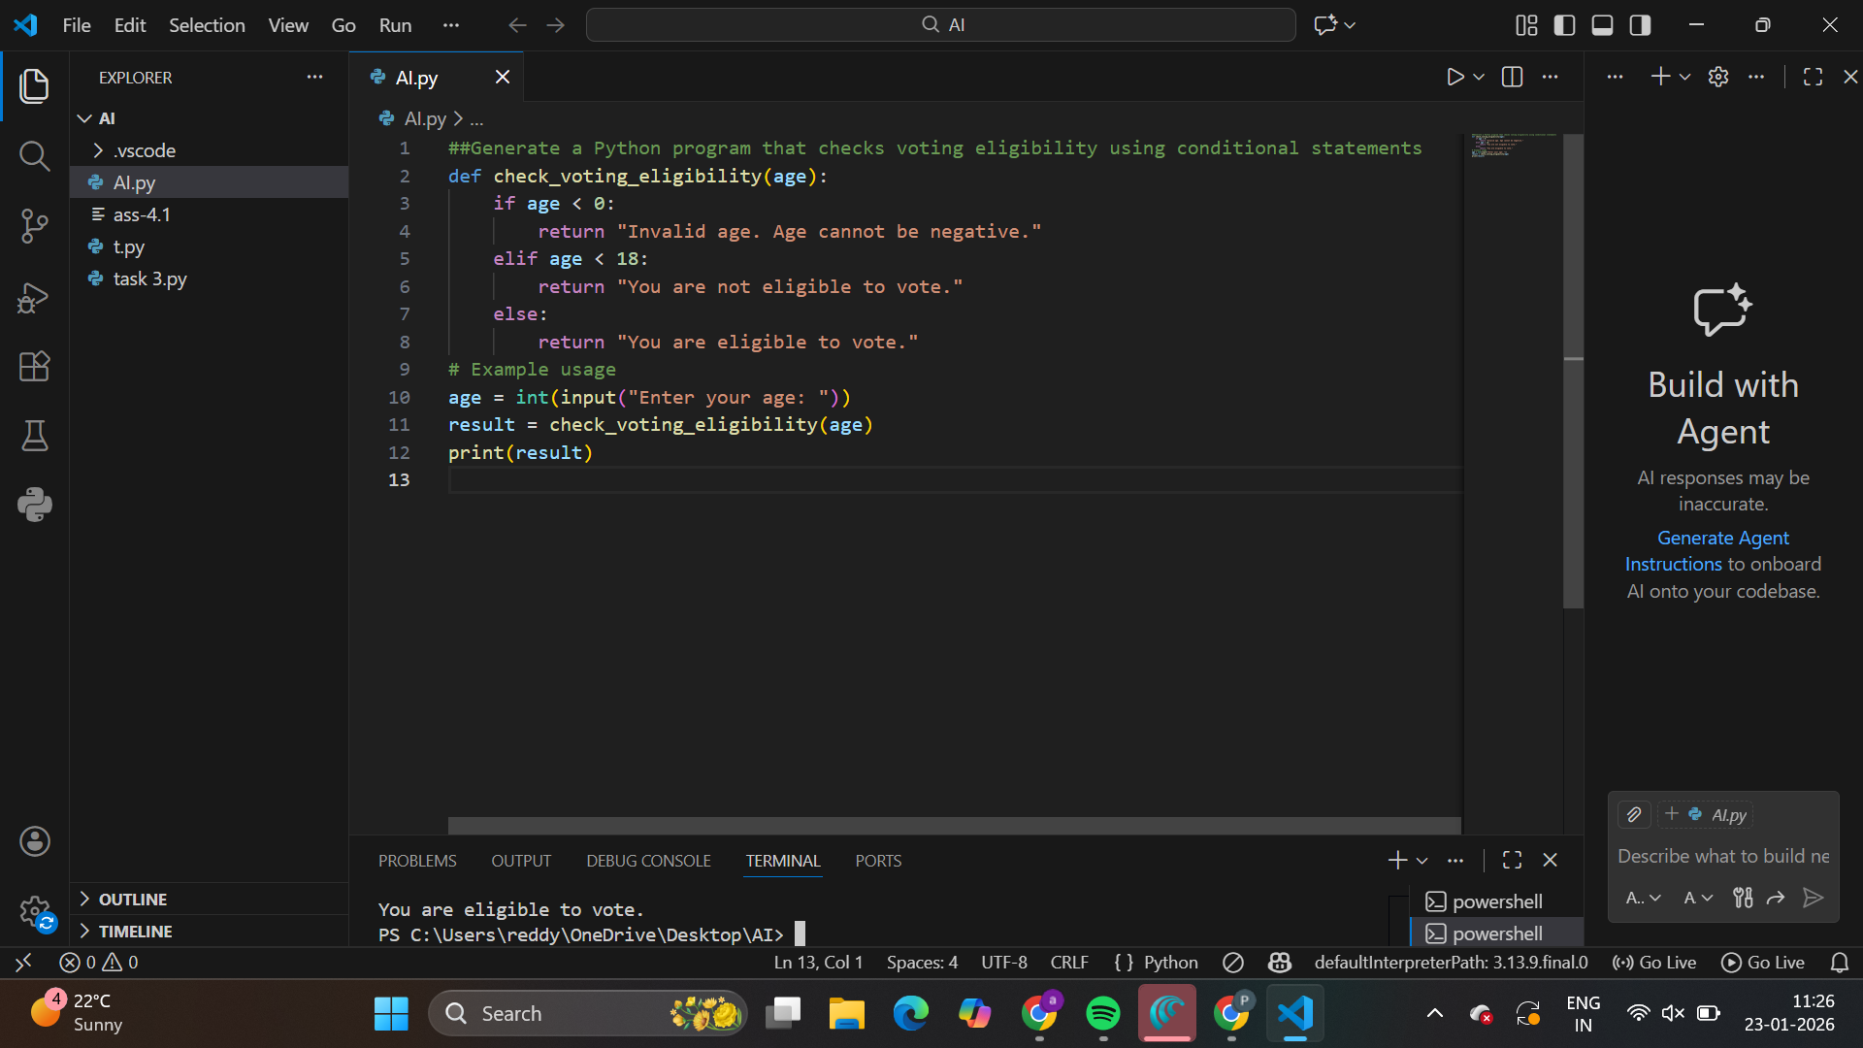

Output:

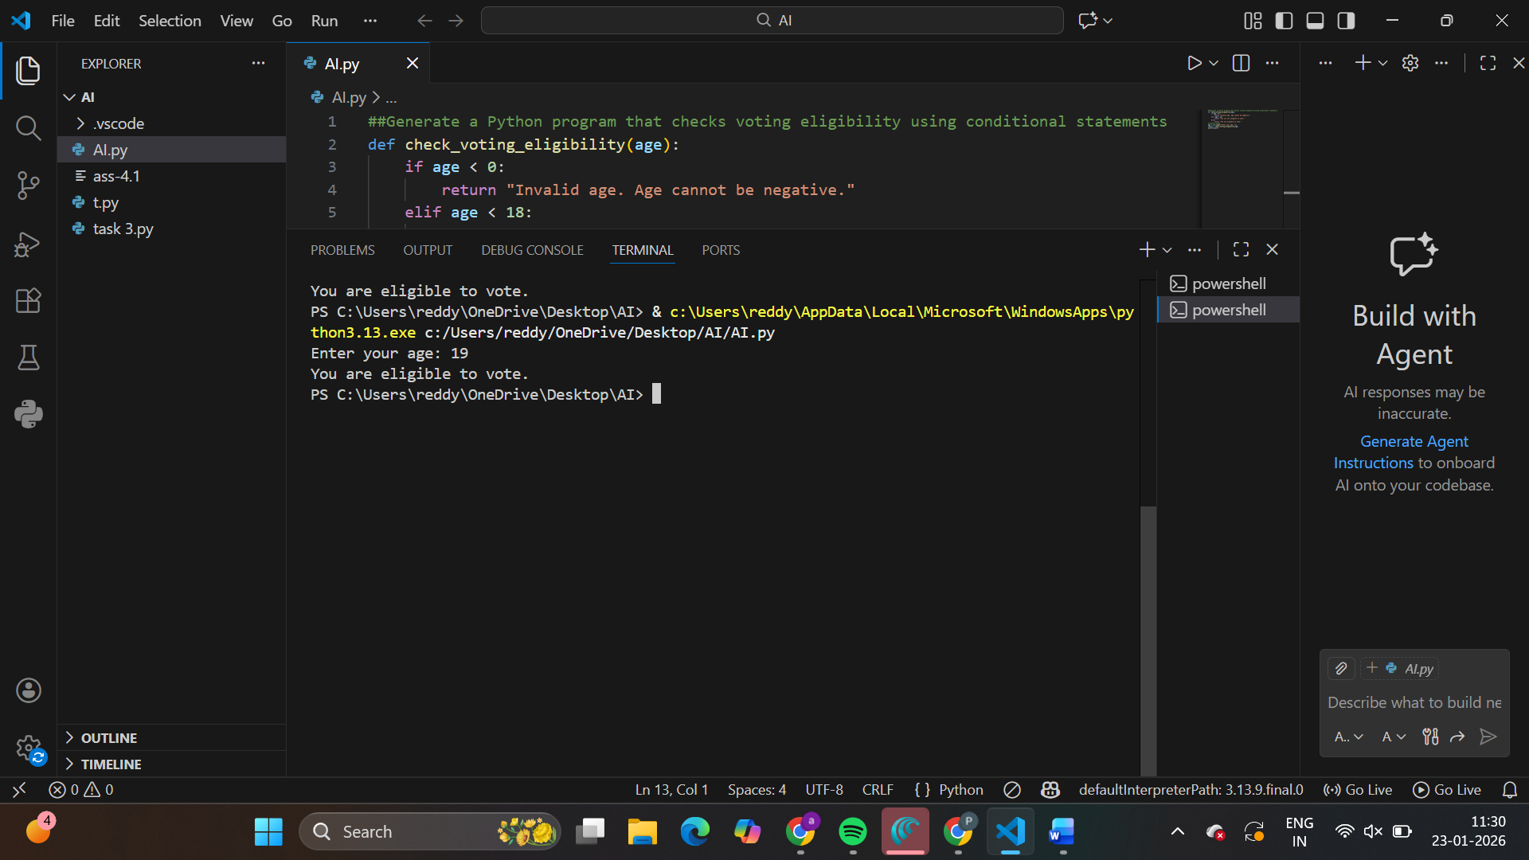

**Task Description #2**(AI-Based Code Completion for Loop-Based

String Processing)

Task: Use an AI tool to process strings using loops.

Prompt:

“Generate Python code to count vowels and consonants in a string

using a loop.”

Expected Output:

• AI-generated string processing logic.

• Correct counts.

• Output verification.

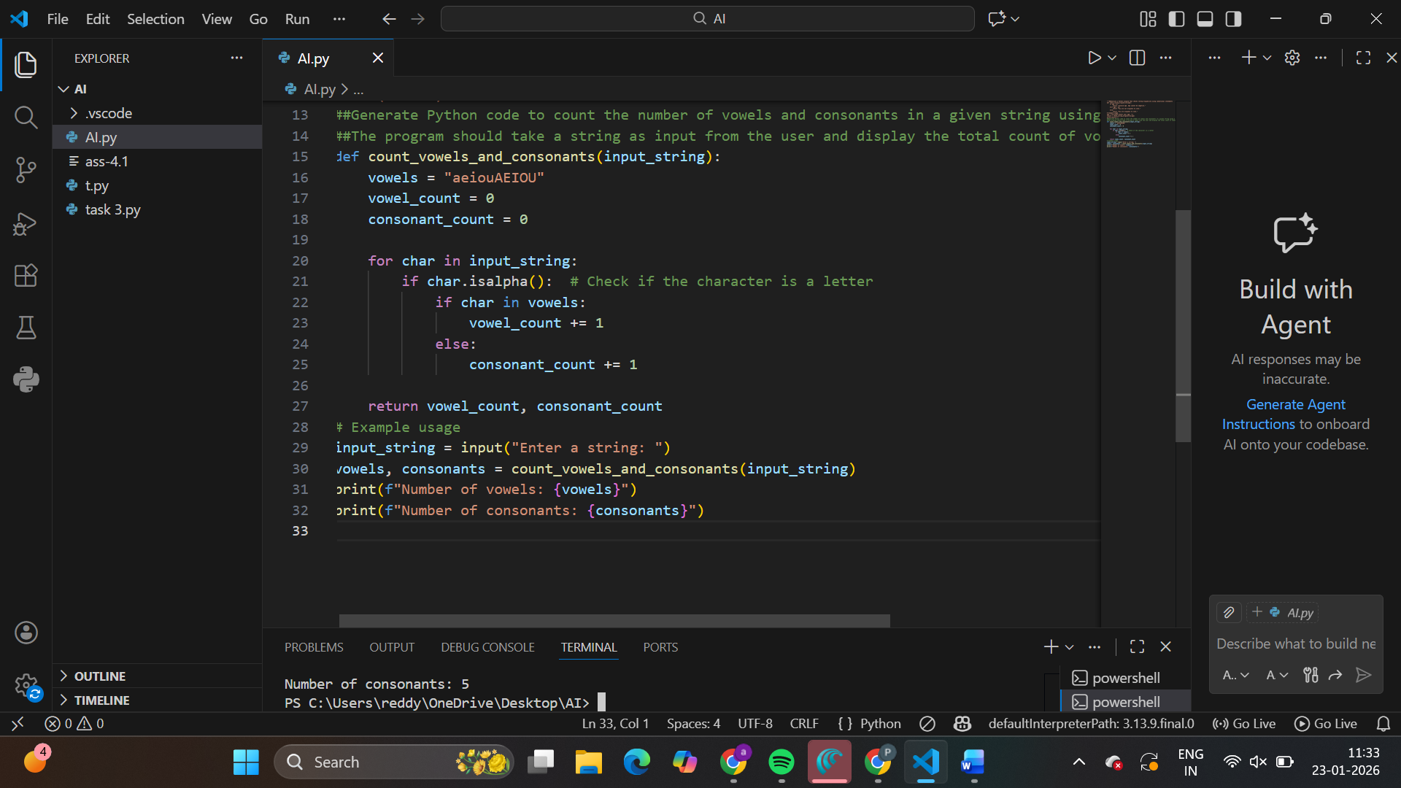

Output:

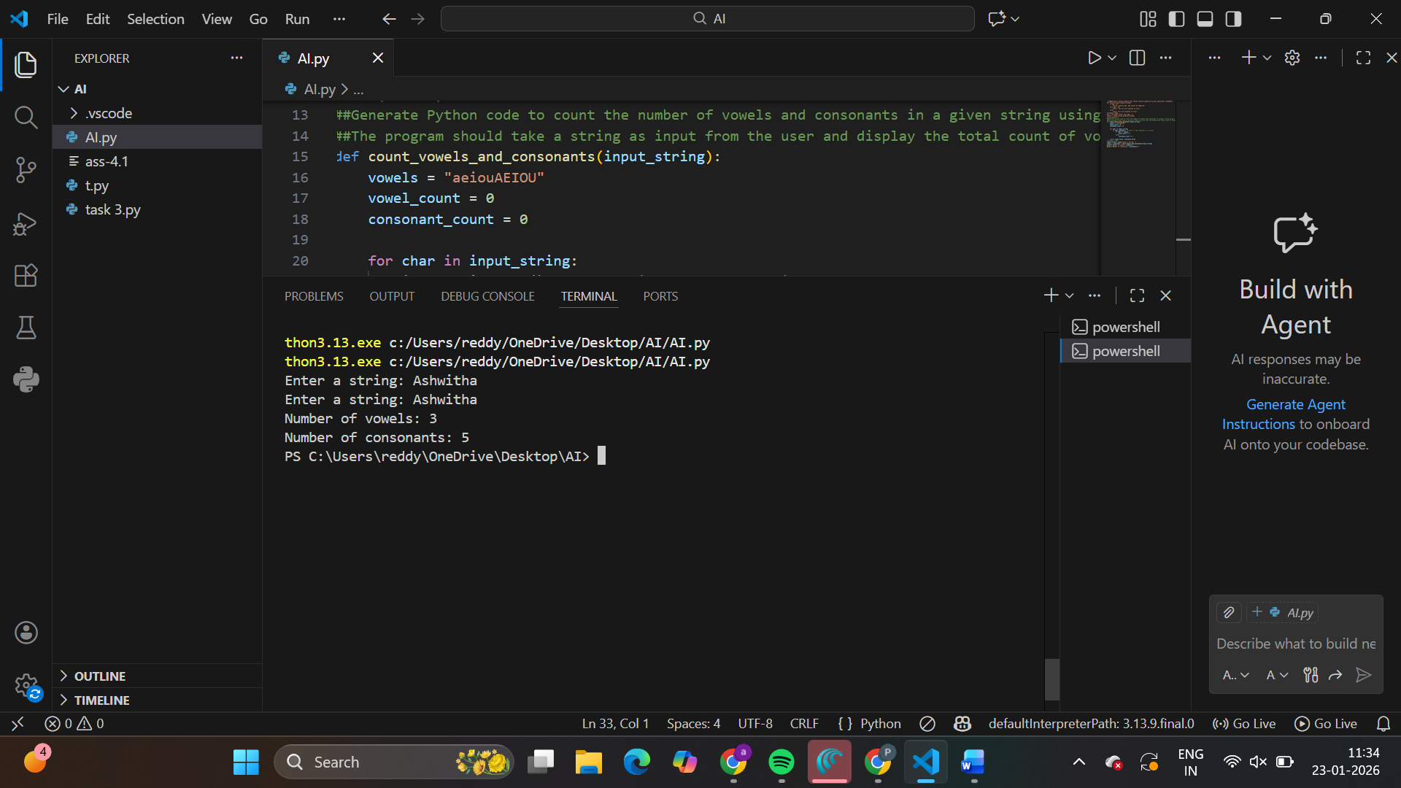

**Task Description #3** (AI-Assisted Code Completion Reflection

Task)

Task: Use an AI tool to generate a complete program using classes,

loops, and conditionals.

Prompt:

“Generate a Python program for a library management system

using classes, loops, and conditional statements.”

Expected Output:

• Complete AI-generated program.

• Review of AI suggestions quality.

• Short reflection on AI-assisted coding experience.

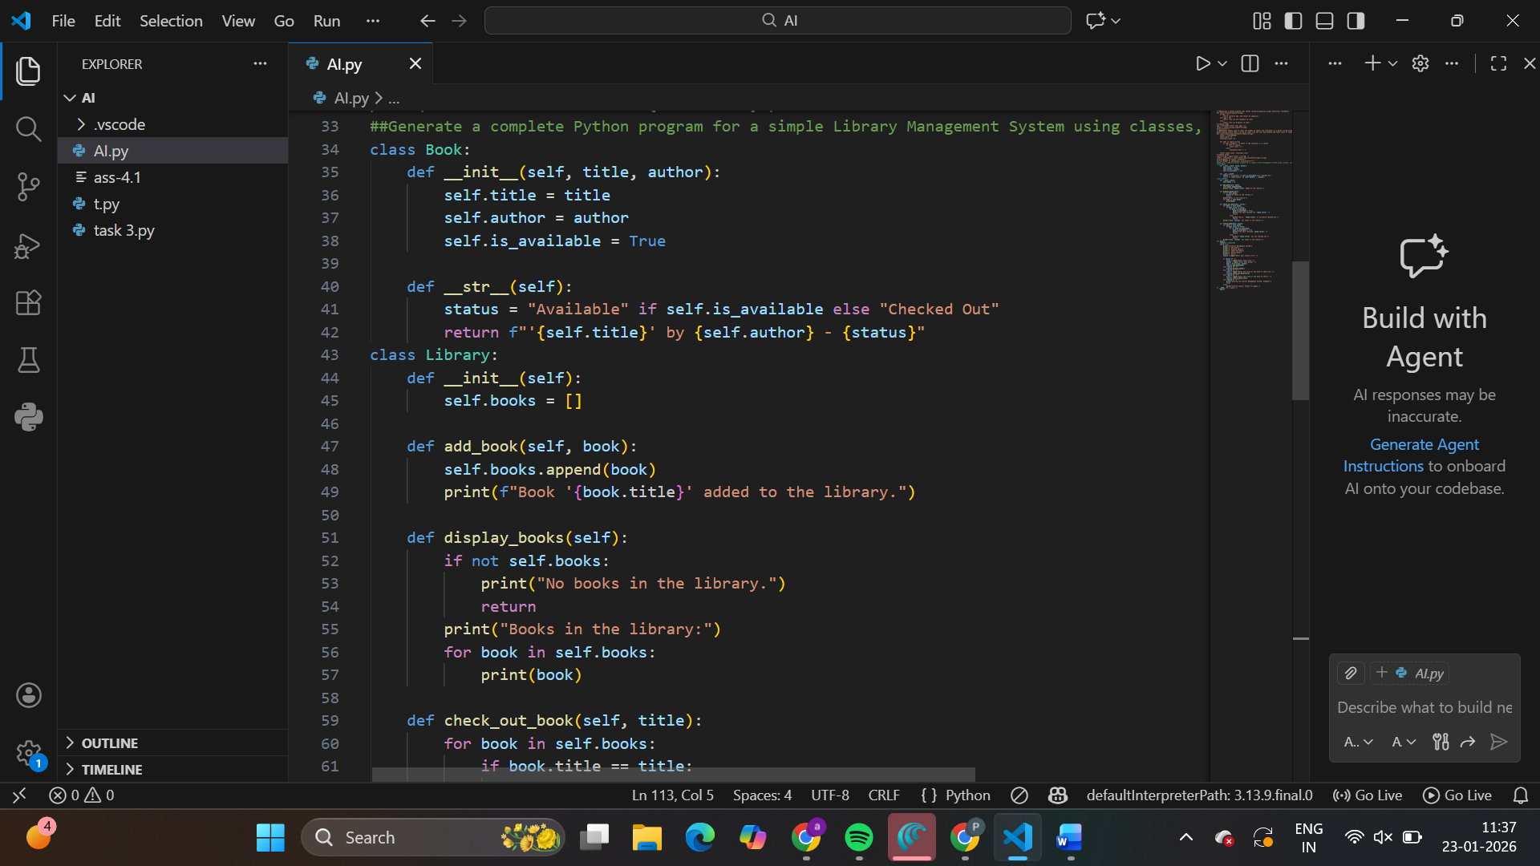

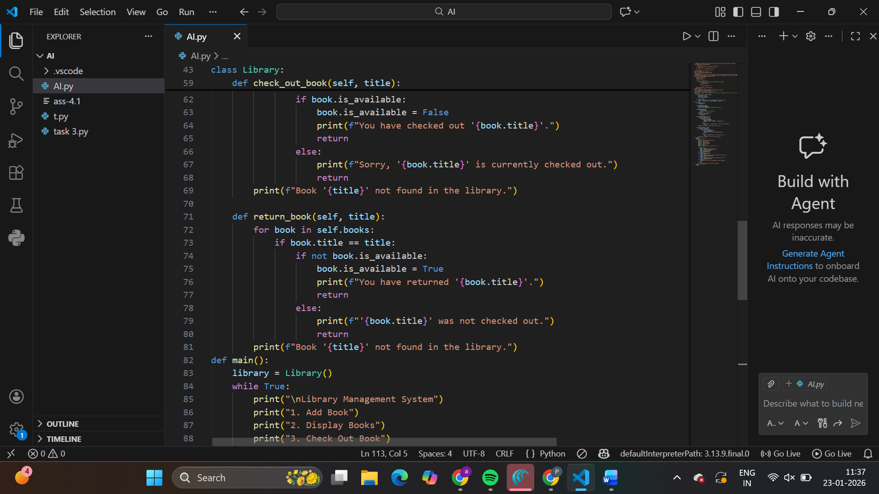

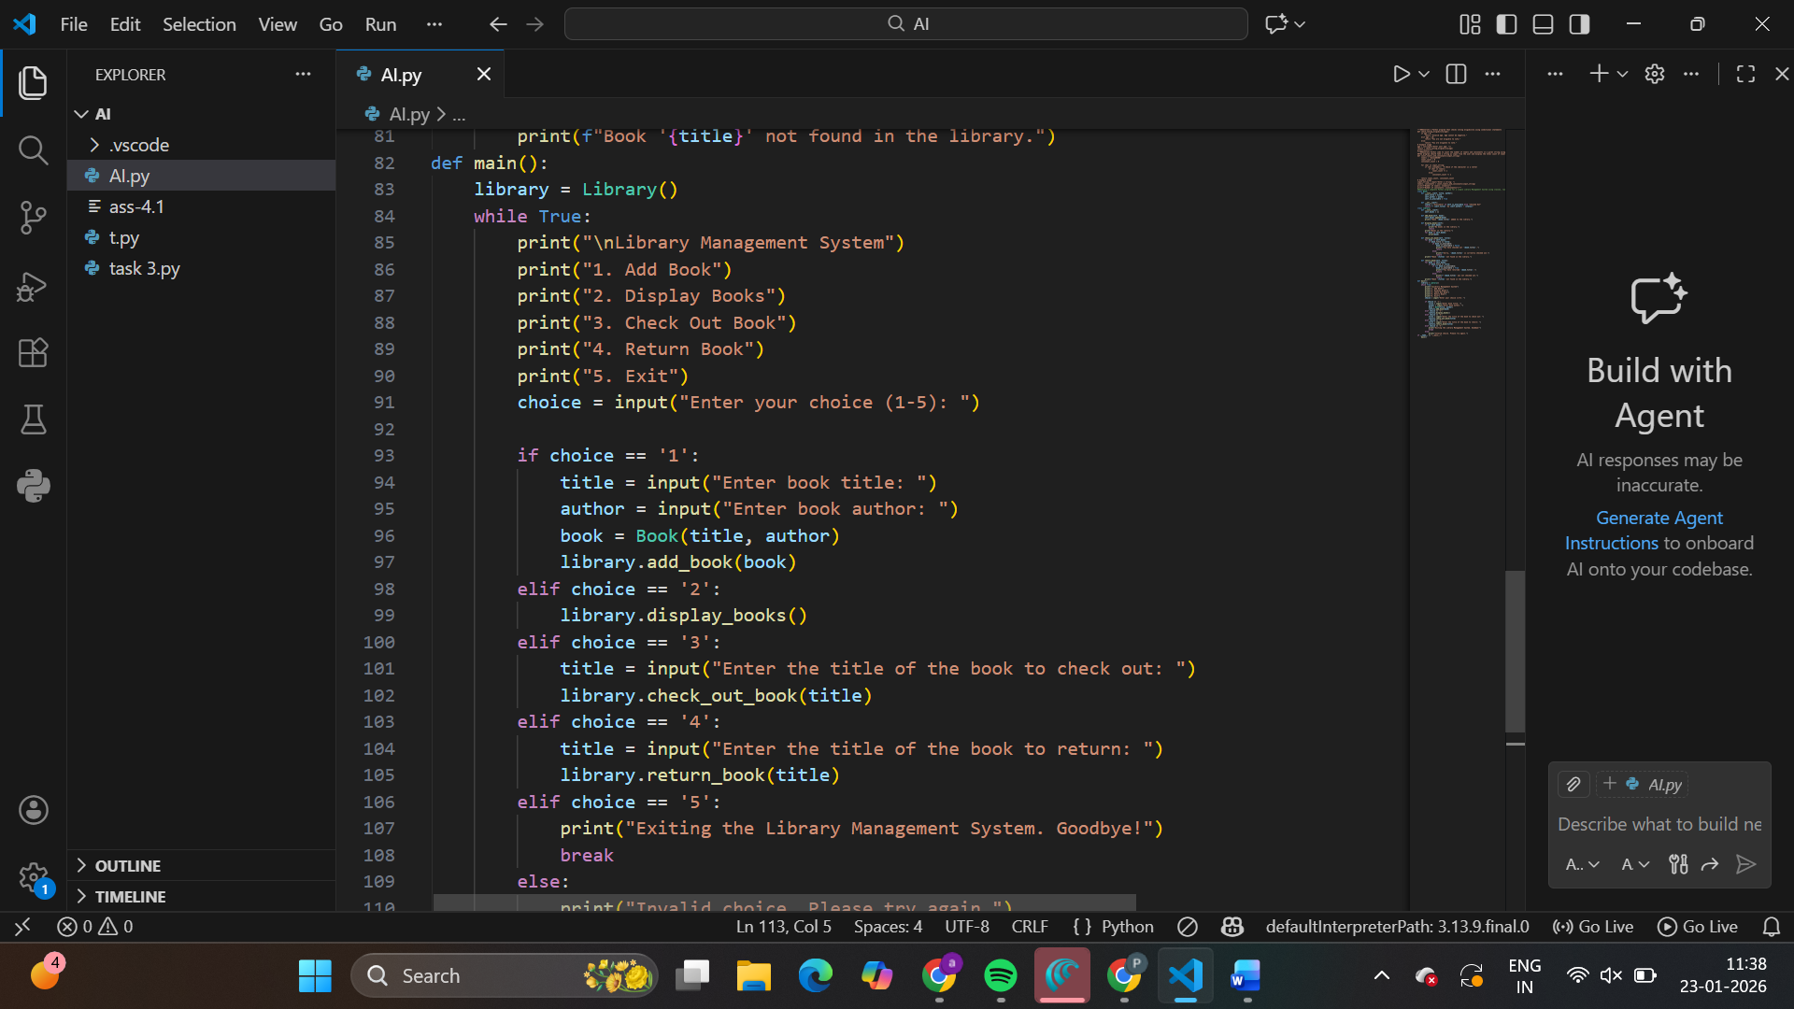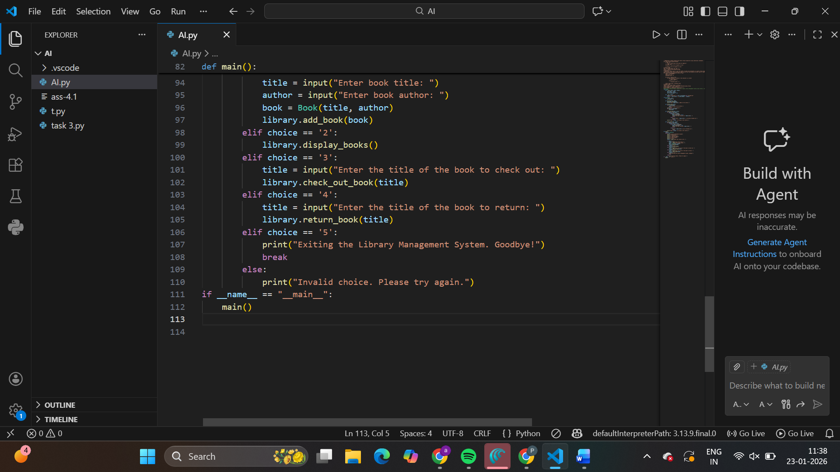

Output:

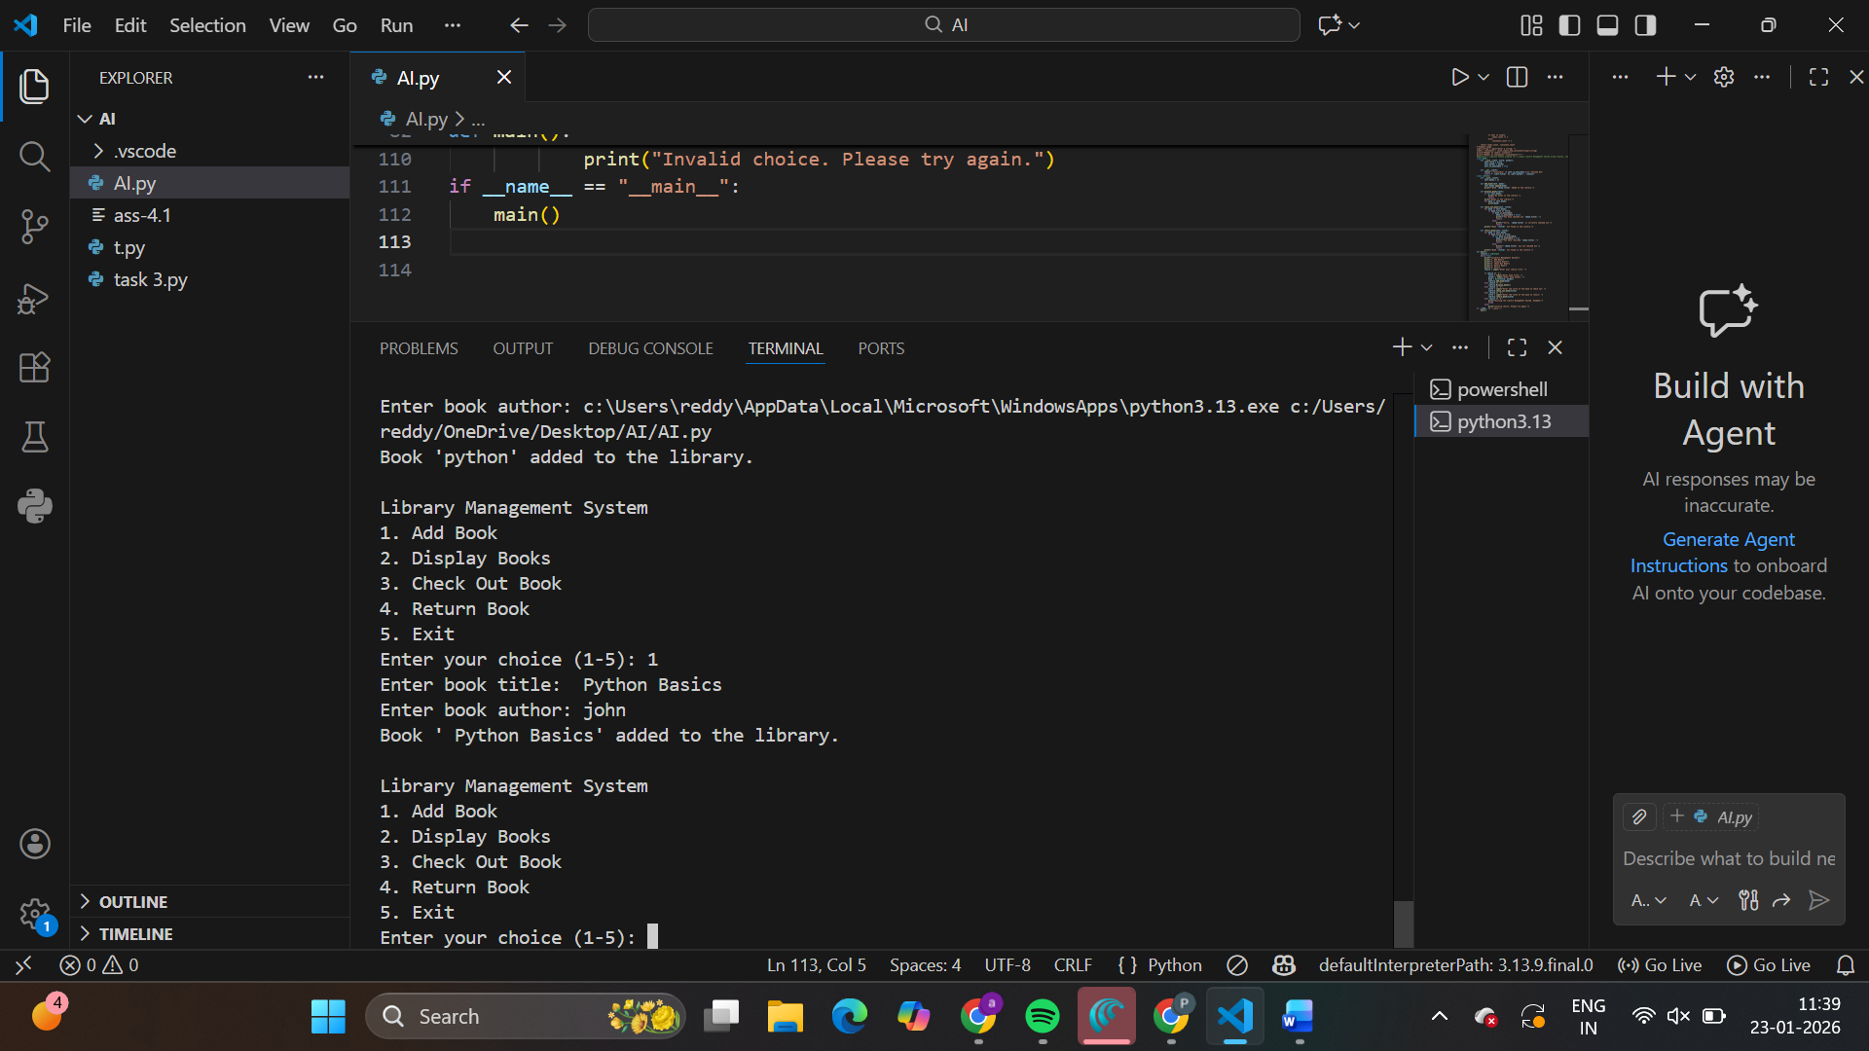

**Task Description #4** (AI-Assisted Code Completion for Class-

Based Attendance System)

Task: Use an AI tool to generate an attendance management class.

Prompt: “Generate a Python class to mark and display student

attendance using loops.”

Expected Output:

• AI-generated attendance logic.

• Correct display of attendance.

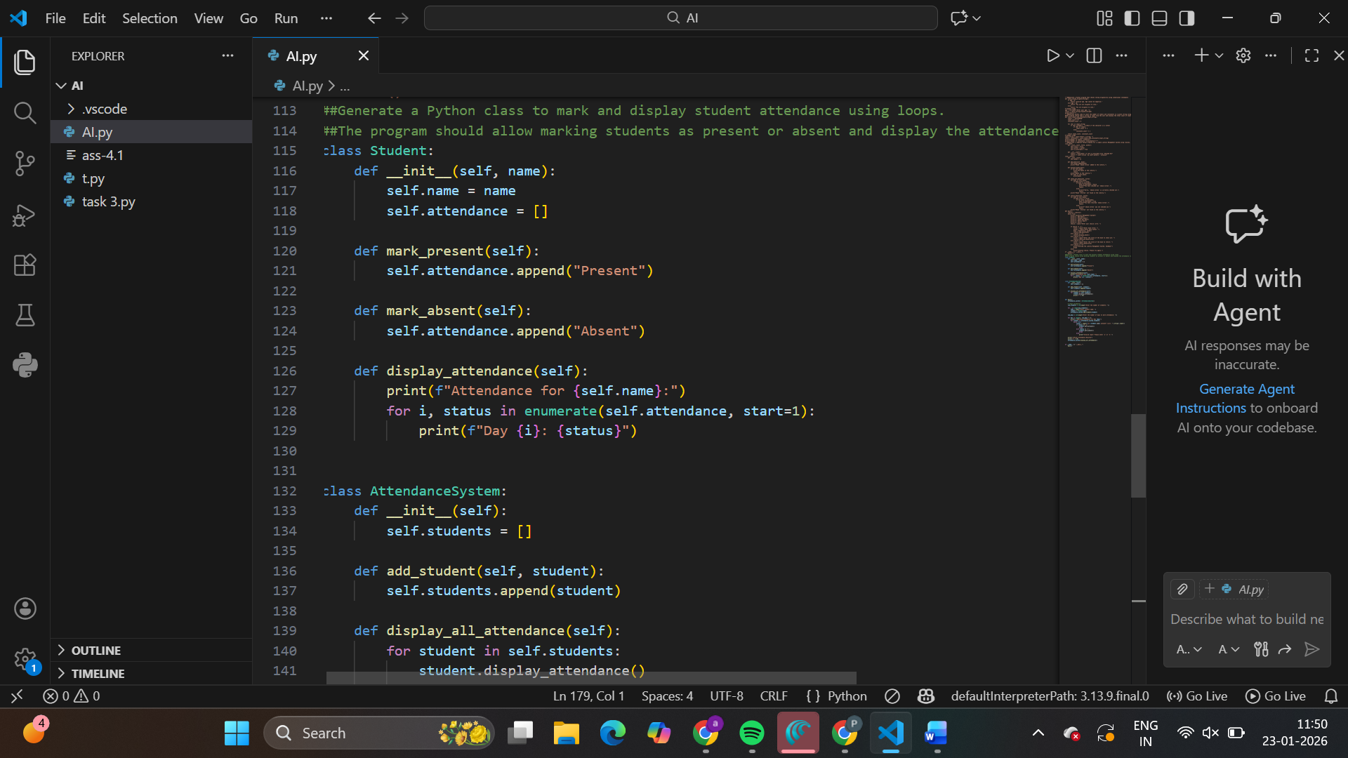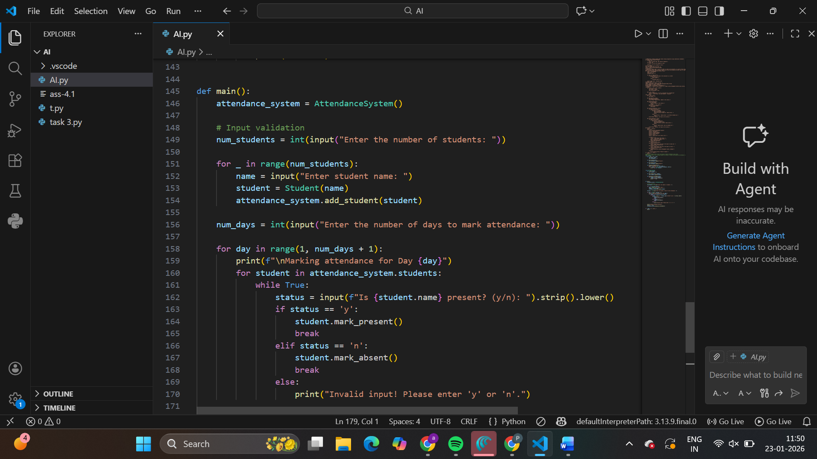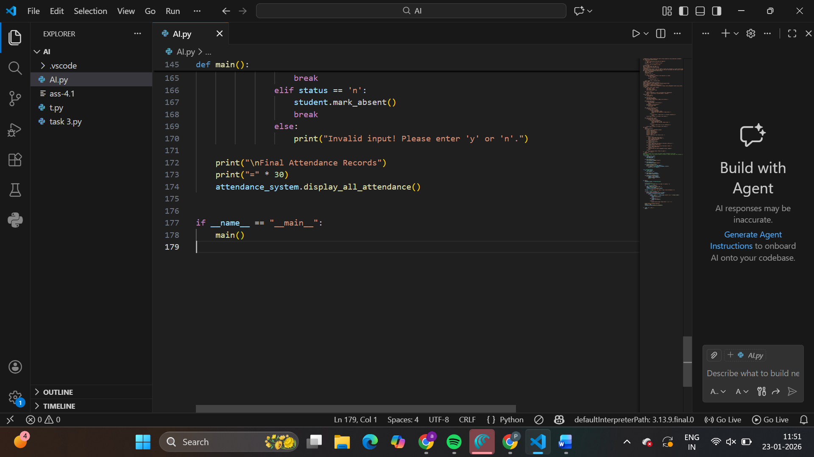

Output:

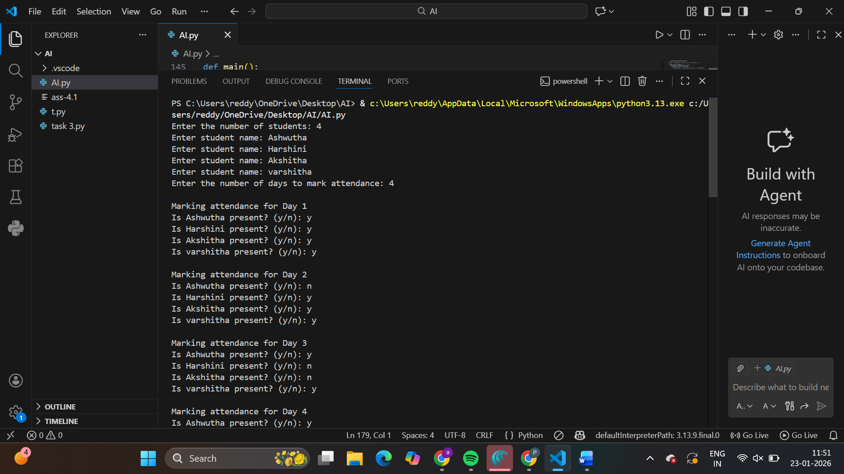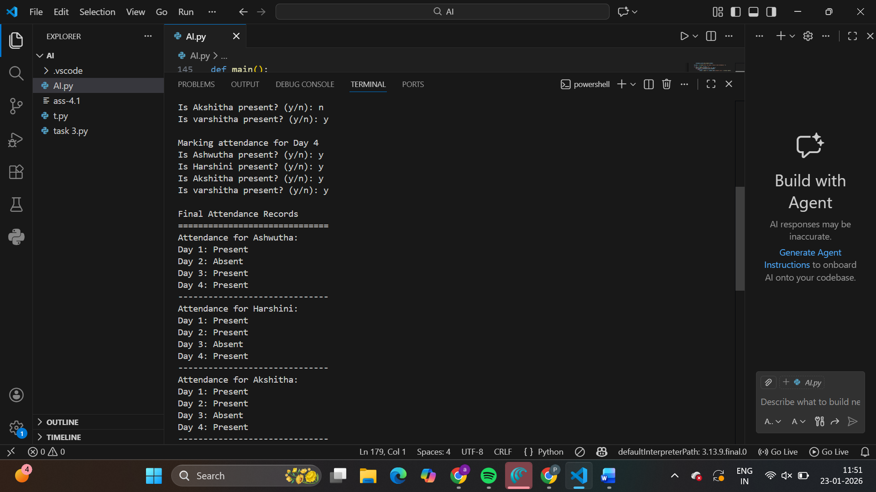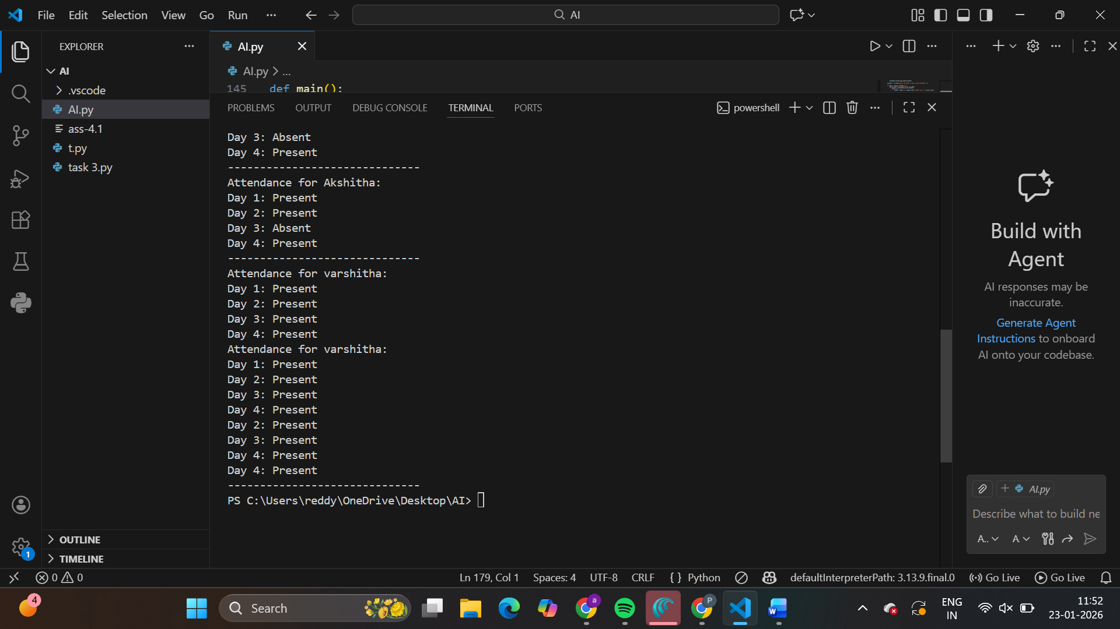

**Task Description #5** (AI-Based Code Completion for Conditional

Menu Navigation)

Task: Use an AI tool to complete a navigation menu.

Prompt: “Generate a Python program using loops and conditionals

to simulate an ATM menu.”

Expected Output:

• AI-generated menu logic.

• Correct option handling.

• Output verification.

